  - Innovative Startup: Biomedical or Clinical Research Internship
About Praxa Sense

We are Praxa Sense, a young and ambitious MedTech startup located in Delft. Our team is developing ALIS™, an advanced sensor based on diffusing-wave spectroscopy (DWS). ALIS™ not only captures traditional photoplethysmography (PPG) data but also provides a unique blood flow index (BFi). This opens up new possibilities for monitoring vital parameters.

We form a close and informal team with large ambitions and a diverse skill set. We operate in a flat organizational structure where both professionalism and a friendly atmosphere are key.

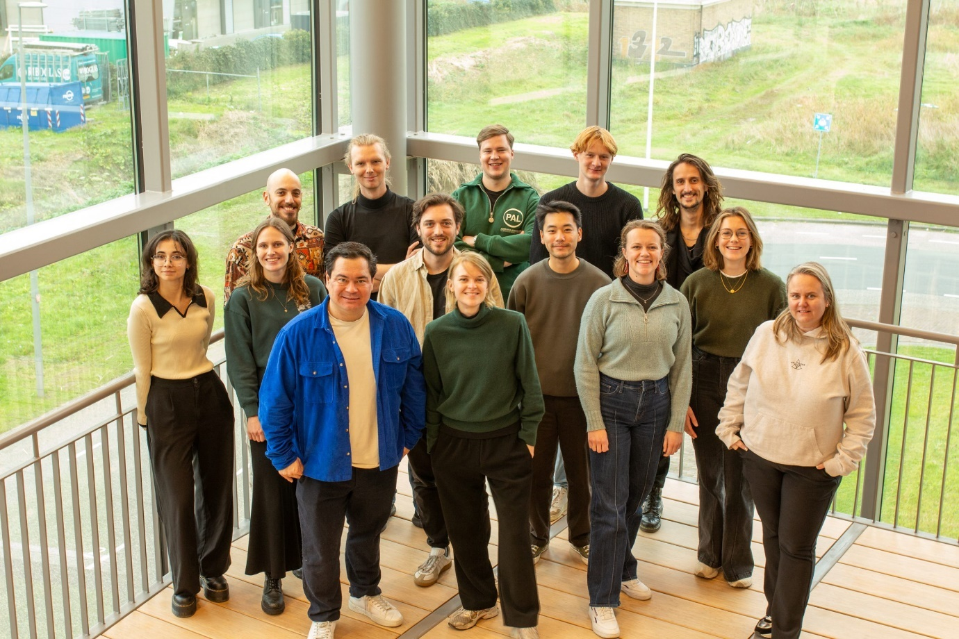

Internship Opportunity
At Praxa Sense, we are constantly working to optimize ALIS™, creating numerous challenges and opportunities in both clinical and technical fields:
- Physiology-oriented project: You will delve into the physiology of a specific vital parameter, analyzing the factors that influence it and uncovering the physiological pathways linking our acquired BFi signal to the parameter.
- Algorithm development project: You will focus on researching and enhancing algorithms to monitor vital functions using ALIS™. Your tasks will include conducting literature reviews, performing signal analysis (proficiency in Python is essential), and participating in tests with our prototypes.
- Clinical study project: You will contribute to the design and execution of clinical studies in collaboration with hospitals. Responsibilities include drafting study proposals, managing logistical aspects, and contributing to the publication of scientific papers.
A combination is also possible. We tailor your internship to align with your interests and skills. Feel free to reach out to discuss which projects suit you best!

Example weekly schedule
A typical week during your internship may include a mix of research, development, testing, and team collaboration: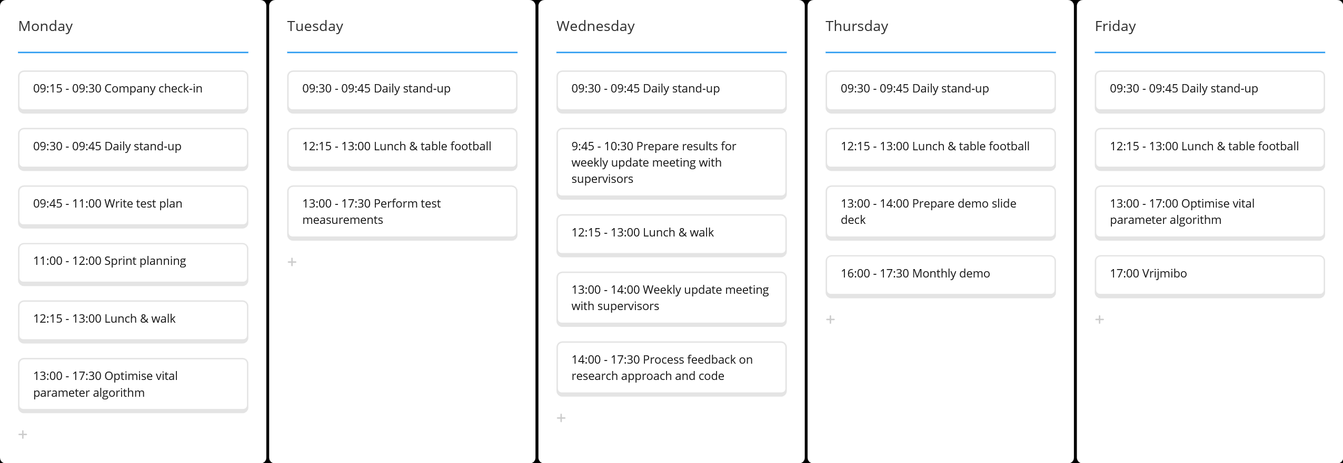
What we offer:
- An internship of preferably 3 months or longer.
- A monthly internship compensation of €400.
- Guidance from a professional and friendly team of clinical technologists, sensor developers, and software engineers.
- The opportunity to contribute to the development of a product with real-world impact in the medical field.
- An inspiring work environment at one of Europe’s largest tech incubators: YES!Delft.
- Fun team activities and a friendly, informal work culture.
- Opportunity to be hired after your internship.

What we’re looking for:
- Educational background: You are currently pursuing or have completed a degree in health and technology-related fields.
- Open and communicative: You are comfortable seeking help and asking questions when needed.
- Independence and teamwork: You take responsibility for your work but also enjoy collaborating with others. You are eager to discuss and tackle complex challenges.
- Ambitious mindset: You are excited about the dynamic and flexible world of a startup.

Interested? Send your motivation letter and CV to: hr@praxasense.com

